**INCOME ANALYSIS**

**1. Determining Whether There Are Breaks In the Monthly Turnover Values**

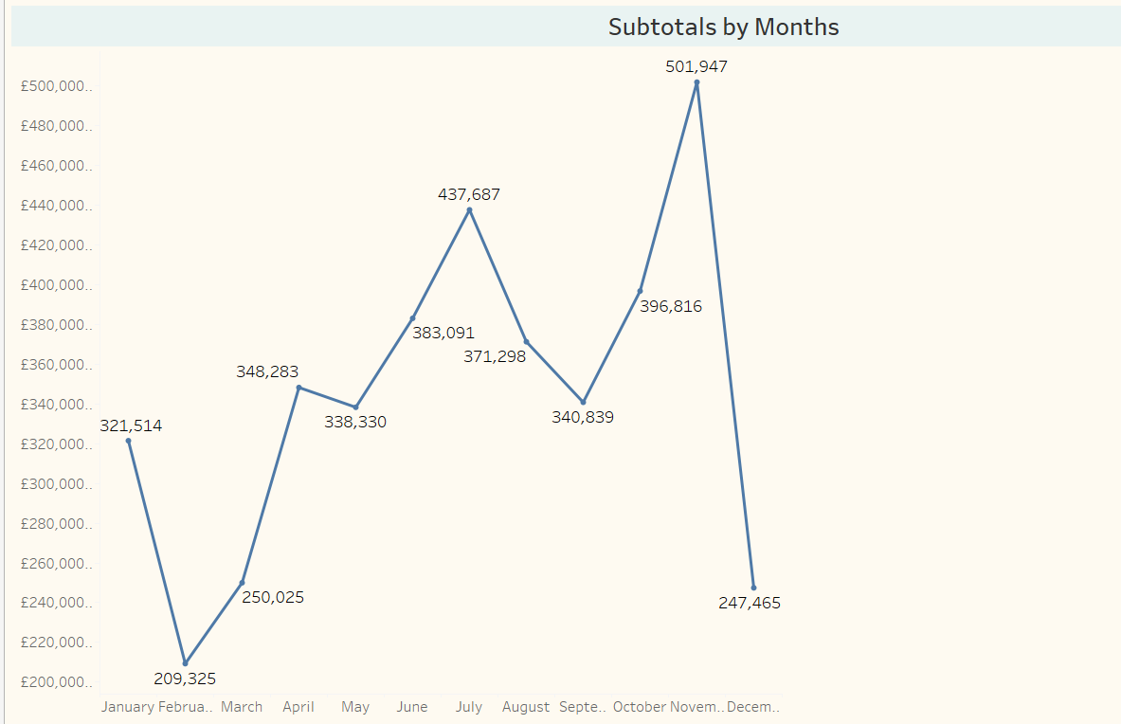

It is observed that there are decreases in the product turnover in January. In February and March, it is observed that the rise continues, but between April and May there is a situation that can be said to be partially sellable. After May, it is seen that the rise continues until July. A decrease is observed in July and August. However, the rise continued from September to December. It is seen that there is a serious decrease in December. The reason for this is thought to be due to the fact that the dataset we have contains the latest data dated December 9th. In fact, since there is no data on the whole month, a healthy evaluation cannot be made.

**Comment:** The reason for the decrease in July and August; It is considered that the reason for the rise from September to December may be due to the high season.

**2. Determining Whether There is a Break in The Turnover Values of The Months of Each Year**

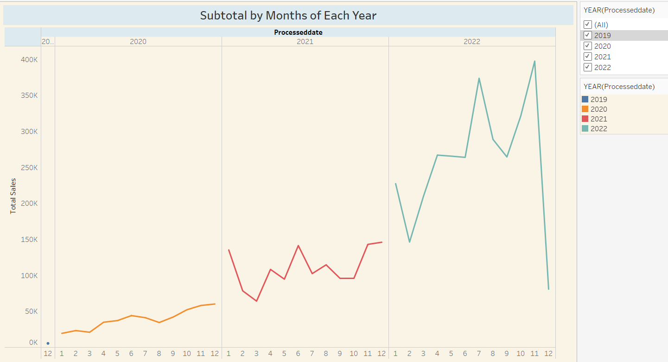

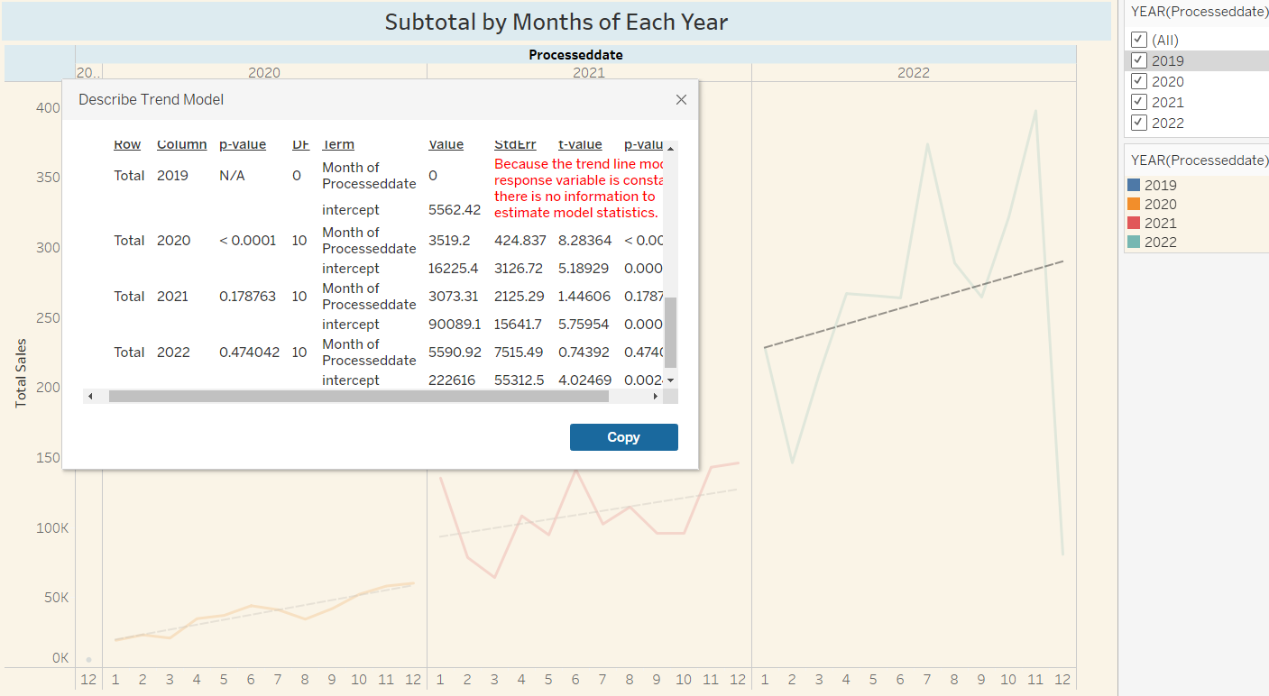

Since sales started in December 2019, 2019 was not included in the evaluation. When the graph is analyzed, while a linear sales trend is observed in 2020, slight ups and downs are observed in 2021. However, although there are sharp ups and downs in sales for 2022, there is a similarity between 2021 and 2022. When we examine the p-value values for 2021 and 2022, it is understood that there is no significant difference between the sales of these two years.

**3. Causality Analysis: Effect of War on Sales, Inflation in Turkey, Expectation in Turkish exchange rate, Covid-19 etc.)**

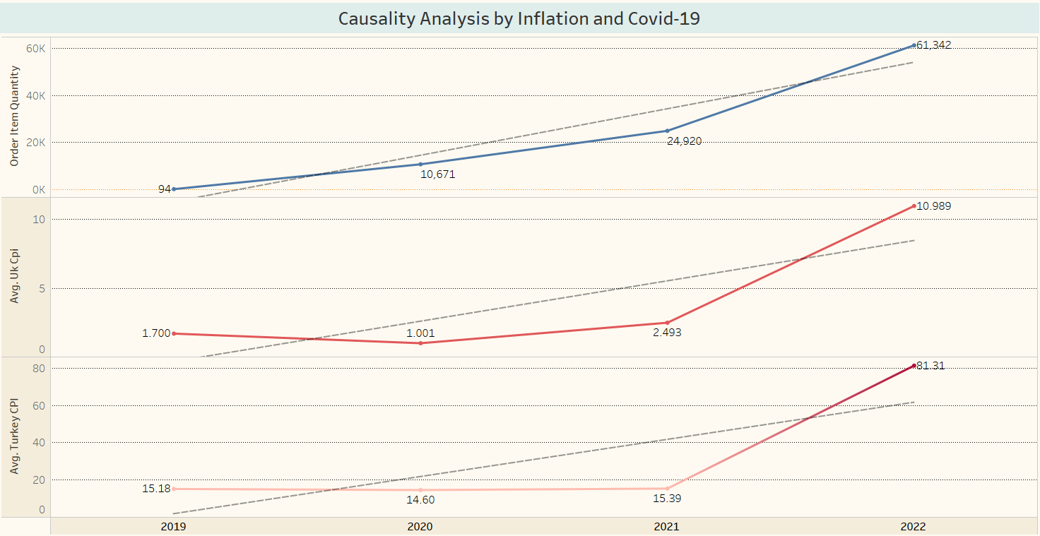

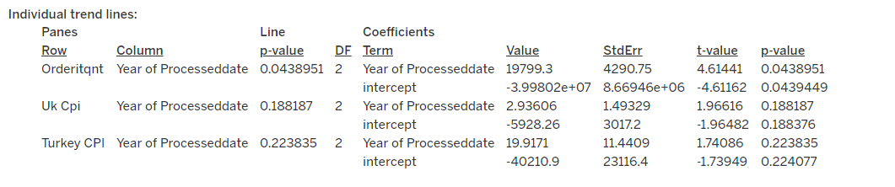

As can be seen in the above trend-line chart, the p-value of the order item quantity is 0.043, the p-value of the United Kingdom's inflation feature is 0.18, and the p-value of Turkey's inflation feature is 0.22. According to this result, it is understood that there is no significant difference between the annual average inflation values between Turkey and the United Kingdom and the orders received over the years.

**4. Is there a difference between the average monthly sales amounts on the sales platforms? (A/B Analysis)**

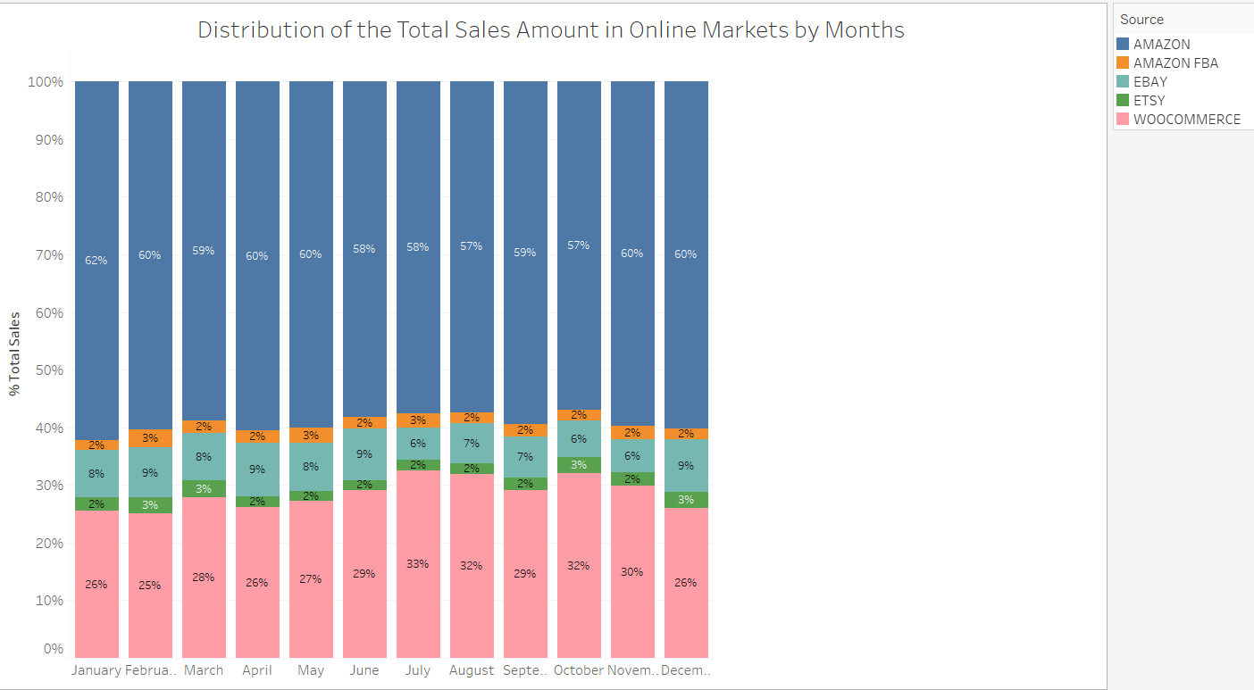

In the A-B Analysis; It is seen that the highest monthly sales in online markets are made on Amazon with a range of 57%-62%, Woocommerce as the second with a range of 26-33%, and EBAY as the third with a range of 6%-9%. Monthly sales on Amazon FBA and ETSY vary between 2% and 3%.

**5. In the light of Time Series Analysis, the maximum profitability that can be obtained in the sales to be made within the next six months**

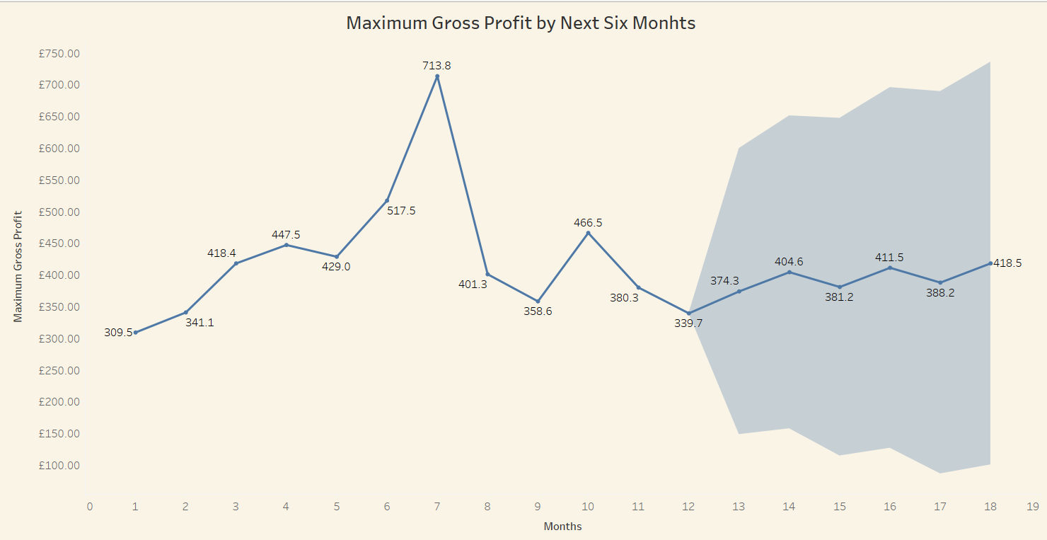

**Describe Forecasts**



Maximum profitability is expected to continue “poorly” over the next 6 months.

**6. Similarity of sales volumes of sales platforms (Effect Size Analysis)**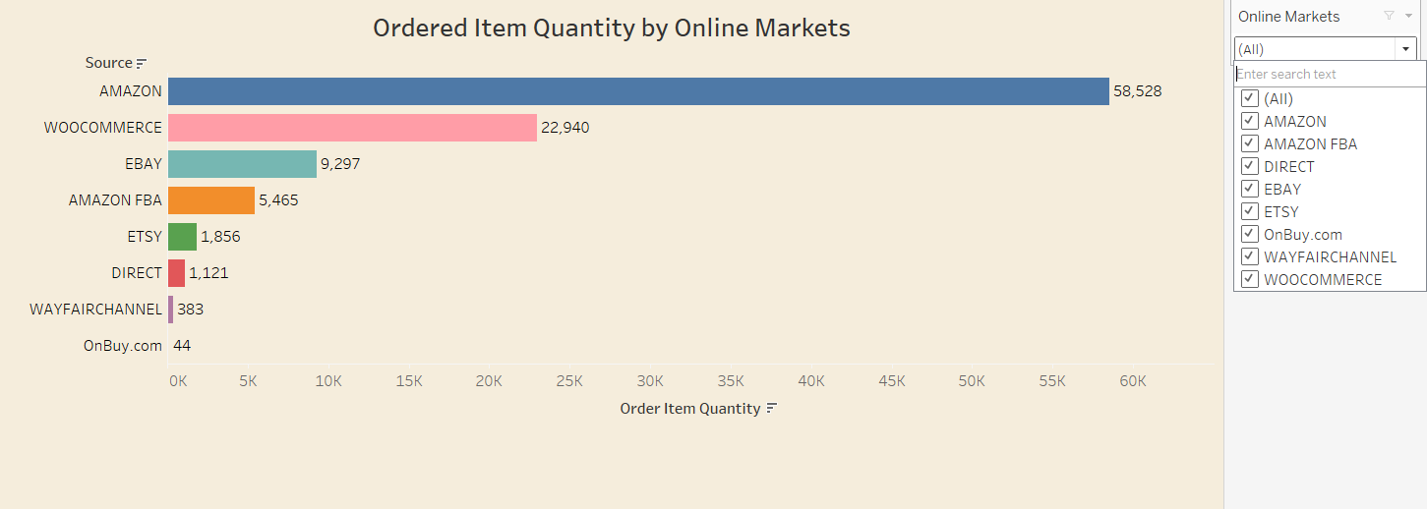

In online markets; Amazon is in the first place with 58528 sales, in the second place is Woocommerce with 22940 sales, followed by EBAY, Amazon FBA, ETSY and others. Sales volumes differ according to sales platforms.

**7. UK Monthly Sales Changes**

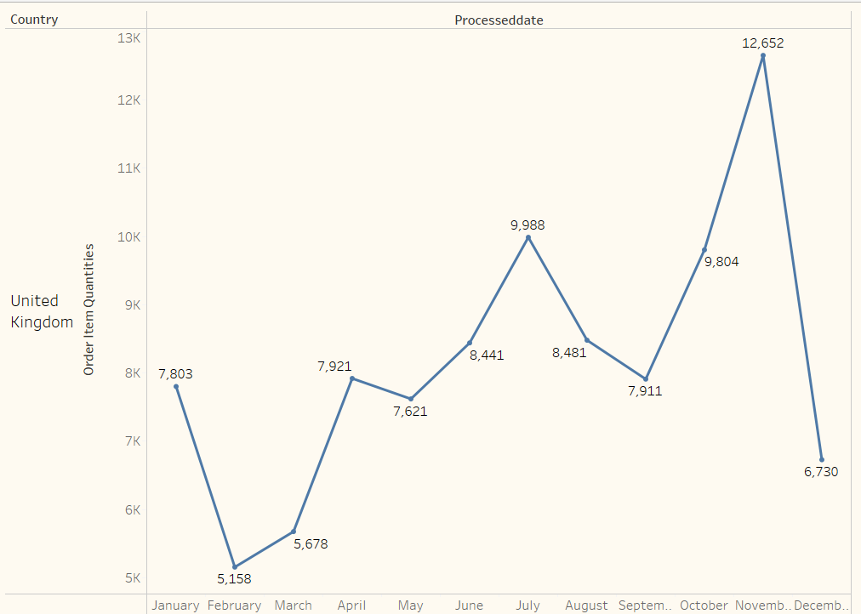

Ingilteredeki urun satislari ile aylik ciro arasinda benzerlik gozlemlenmektedir. Ocak ayinda dusus yasandigi, subat ve mart aylarinda ise, yukselisin devam ettigi ancak nisan ve mayis aylari arasinda kismen satabil denilebilecek bir durum yasandigi gozlenmektedir. Mayis ayindan sonra, temmuz ayina kadar yukselisin devam ettigi fakat temmuz ve agustos aylarinda dusus yasandigi gorulmektedir. Buna mukabil, eylul ayindan itibaren aralik ayina kadar yukselis devam ettigi gorulmektedir. Aralik ayinda ise, ciddi bir dusus yasandigi gozlenmektedir.

**Comment:** The reason for the decrease in July and August; since it is a holiday season, it is considered that the reason for the rise from September to December may be due to the high season. The reason for the decrease in sales in December is considered to be due to the fact that the dataset we have contains the latest data dated December 9th. In fact, since there is no data on the whole month, a healthy evaluation cannot be made.

**8. Satışlardaki Aylık Satış Trendleri (Line Grafik)**

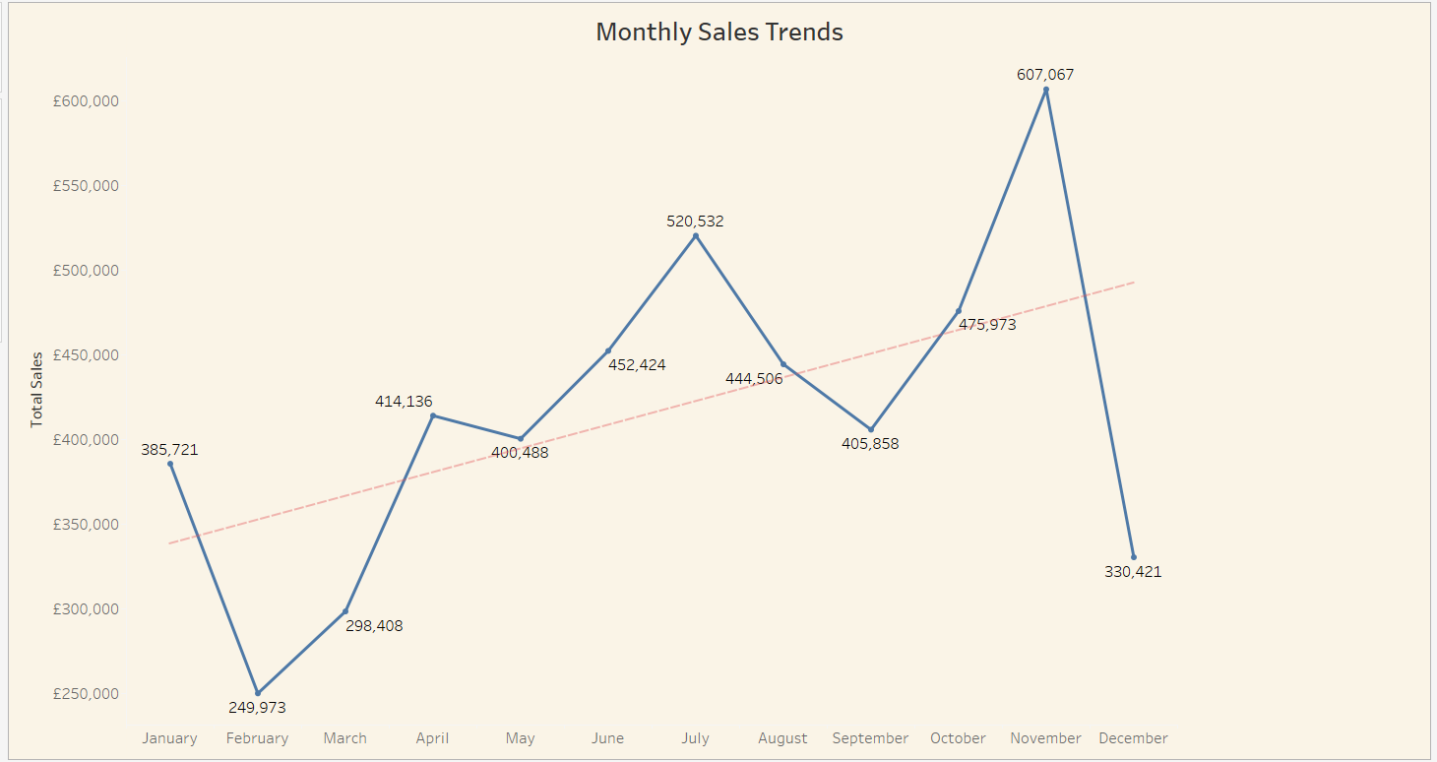

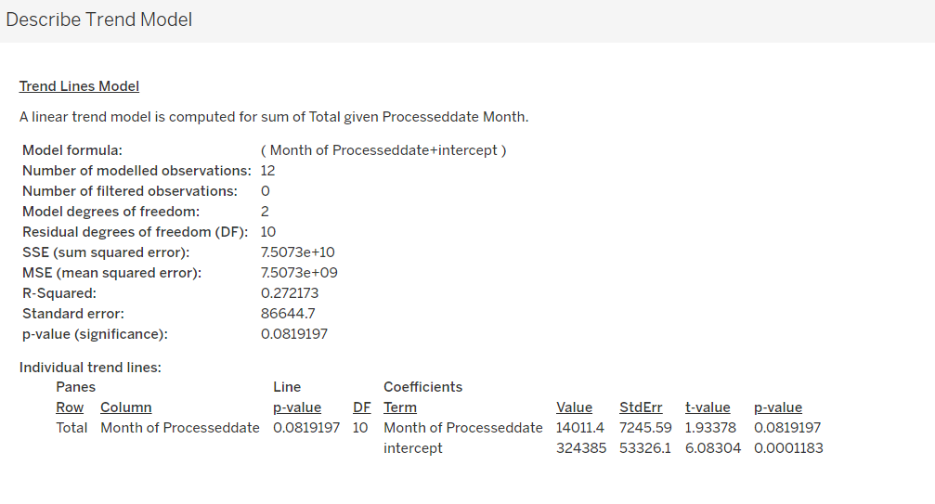

The P-value is seen as 0.081. Since this value is greater than 0.05, it shows that there is a significant difference between monthly sales trends.

**9. Distribution of Orders, Sales and Profits in the UK**

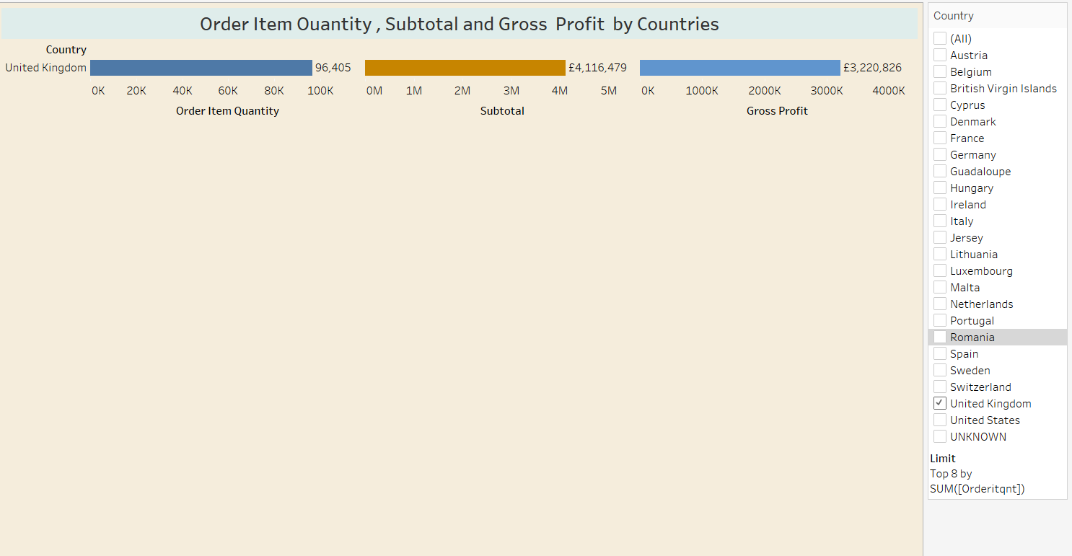

**Distribution of Order, Sales and Profits in the Top 8 Countries Except UK**

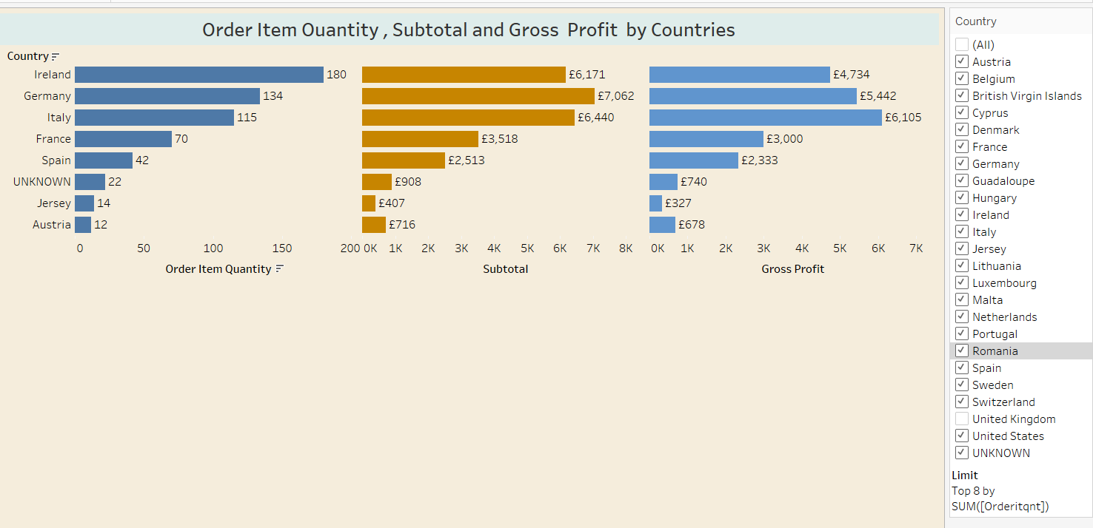

There are eight countries where the company receives the highest number of orders after the UK. Since the order numbers of other countries are 1, they are not shown in this chart. In these countries; when the number of orders, sales and gross profits are examined, it is seen that there is a correct ratio in countries other than the first 3 countries. For example, although the number of orders in Ireland is more than Germany and Italy, it is understood that the subtotal and profit are less than these countries. From these results, it can be understood that the carpet preference of the countries varies according to the price and the type of carpet.

**10. Reklam Harcamaları ve Gelir Arasindaki Iliski**

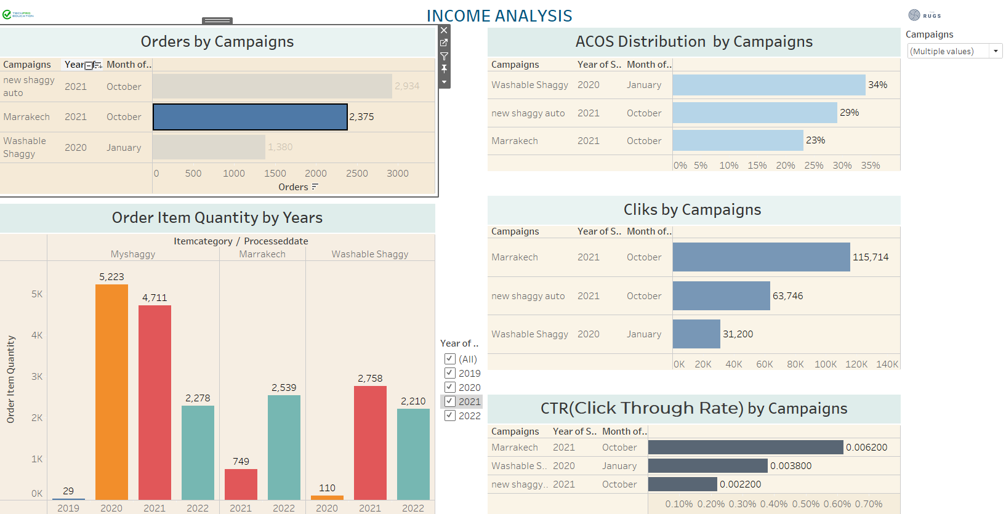

**Recommendation:** First of all, we need to be able to establish a relationship between the 'Sales and Amazon campaigns' tables so that we can measure the relationship between advertising expenditures and revenue. First of all, it is necessary to know which product category the advertisement application is applied to. Since this match could not be made properly, a relationship was tried to be established between the campaign names and the product category names in the sales table.

Therefore, it is evaluated that a healthy analysis can be made by adding the ASIN number in the "Sales" table to the "Amazon campaigns" table.

**Comment:** It is seen that the advertising campaign for the New Shaggy product was made in October 2021 and 2934 units were sold. When the sales volumes for the years are considered, it is seen that it lags behind the previous year and there is a decrease of approximately 50% in 2022 compared to 2021.

However, when the CTR ratio of the product is considered, it is seen that it is 0.0022 and the sales amount is 2934. Although we do not know the profit margin of the company, it can be said that the sales increased after the advertisement application.